On : January/28/2023

Submitted to : **Sir AHMED ALI**

This is to certify that **FARAZ SIAL, ZEESHAN ZAHID, ASHIR ZAFAR and SAYED RAZA ABBAS KAZMI** have successfully completed their first semester e-project

Certificate of Completion

1) The Home Page should be created making use of Sections with a suitable logo, the header section can be added which will show images of related products.

2) The site must contain the links to navigate through any category for the information.

3) The site should display a menu which will have categories of all products. Few products expected to be included are mentioned below, however more can be added.

* Cameras: all types of cameras should be included
* Camera lenses : varieties of lenses to be included
* Pro audio: related audio accessories options to be included
* Memory cards &amp; media : related products
* Tripods &amp; supports
* Lighting &amp; Studio
* Camera bags &amp; cases
* Miscellaneous accessories

4) The site should contain the options for brief introduction about the various products available, location of the shop and any other information if required.

5) The information should be categorized according to the brand names of the products like if a User wants to see only “yashica” cameras or any other company products then he/she can click on a Link/button/menu etc and can see only that Brand products.

6) When a user selects any particular brand, a list of products for that brand will be displayed

7) A brief summary of features of the respective item should be displayed on the Web Page along with the picture but detailed Features should be stored in Individual Word documents which can be downloaded or viewed by the User who wishes to see the same.

8) The user should also be able to compare the various products of different as well as similar brands.

9) There should be a “Contact Us” page which will have the Address of the Company which should be displayed using GeoLocation API (eg. GoogleMaps) and the email address which when clicked will invoke the local mail client from where they can send an email.

Problem Definition

**Hardware**

* A minimum computer system that will help you access all the tools in the courses is a Pentium 166 or better
* 64 Megabytes of RAM or better

**Software**

* Notepad/HTML editor
* Dreamweaver
* IE 5.0/ Netscape 6.0

**Customer Requirement Specification**

**Architecture and Design of the System**

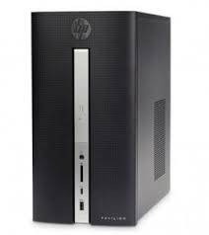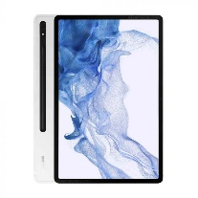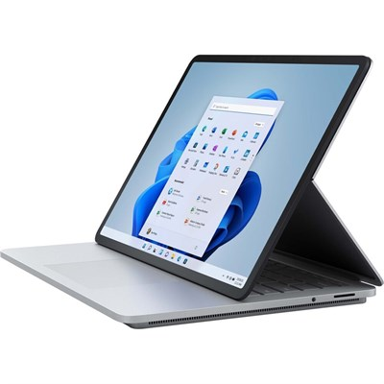

Front end Technologies

( HTML5,

CSS3,

Javascript,

jQuery,

Bootstrap,

Json)

TRIPOD

PAGE

TRIPOD

PAGE

CANON

SONY

PANASONIC

CANON

PAGE

SONY

PAGE

PANASONIC

PAGE

**SITE MAP**

OTHERS

DRONES

TRIPOD

BRANDS

COMPARISON

PAGE

ABOUT US

PAGE

CONTACT US

PAGE

COMPARISON

ABOUT US

HOME

CONTACT US

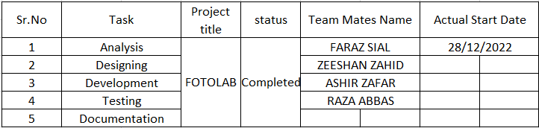

**Acknowledgement**

First of all we would like to thank **Almighty Allah** for giving us strength and ability to complete this project.

And then, we would like to express my special thanks of gratitude to our teacher **Sir AHMED ALI** who guided us on the project **FOTOLAB**, which also helped us in doing a lot of new learning and we came to know about so many new things we are really thankful to him.

And finally we would also like to thank the **E-project teams** and **Aptech** to giving us such a task from which we learnt a lot and that will help in our future development

**Task Sheet**